Create a Web API with SQL and EF
Create a App Service in Azure – don’t delete App Service Plan
Add CORS
builder.Services.AddCors(options =>
{
options.AddPolicy("AllowAll",
policy => policy.AllowAnyOrigin()
.AllowAnyHeader()
.AllowAnyMethod());
});

app.UseCors("AllowAll");

commit and push again
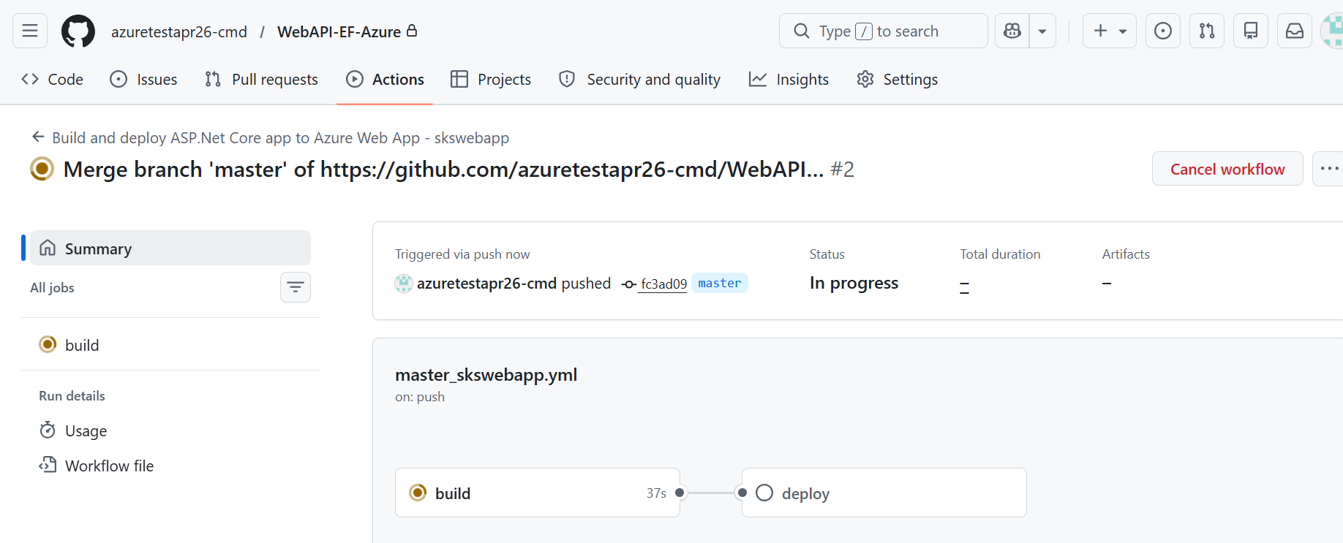

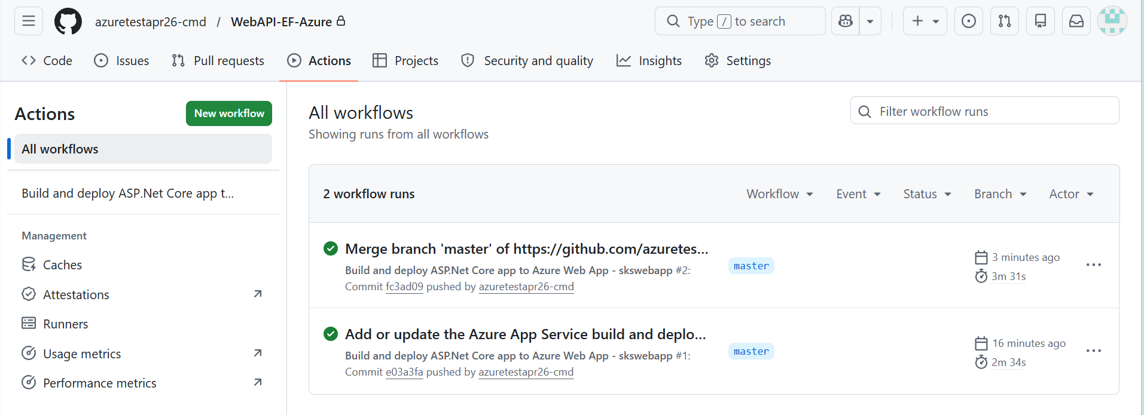

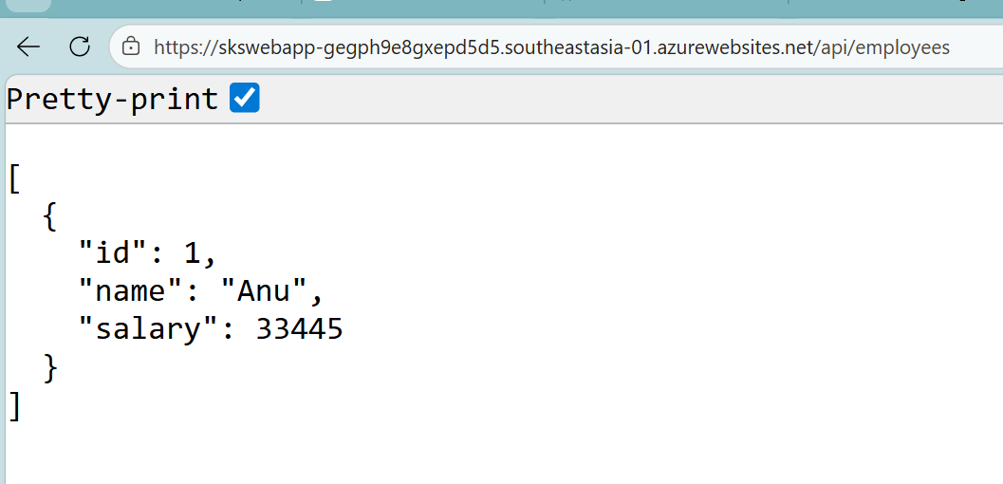

Web App (API) is working fine
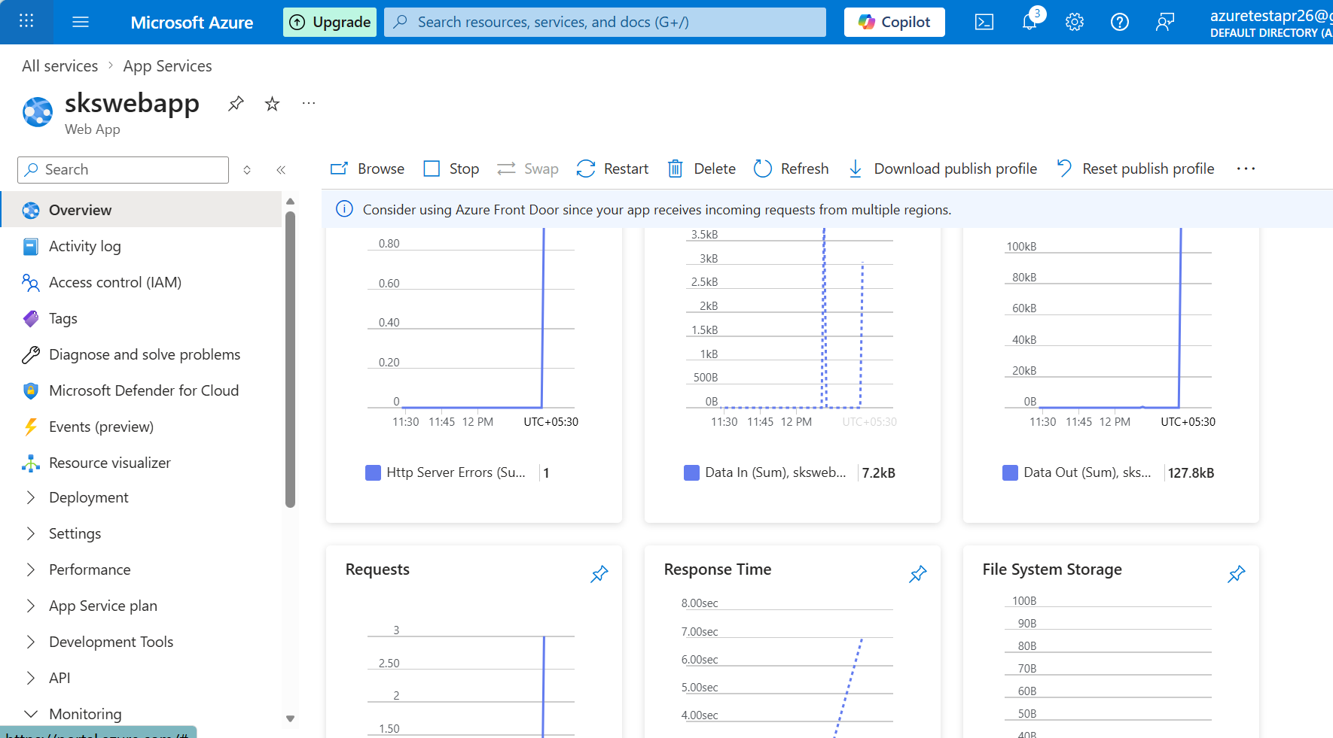

Add APIM

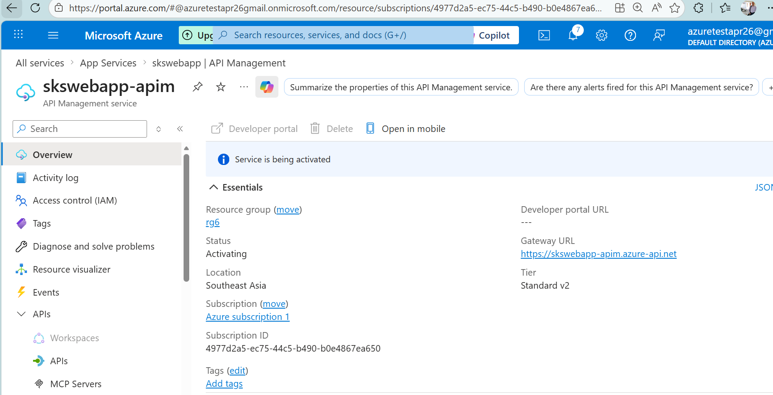

After apim deployed, add api to apim –
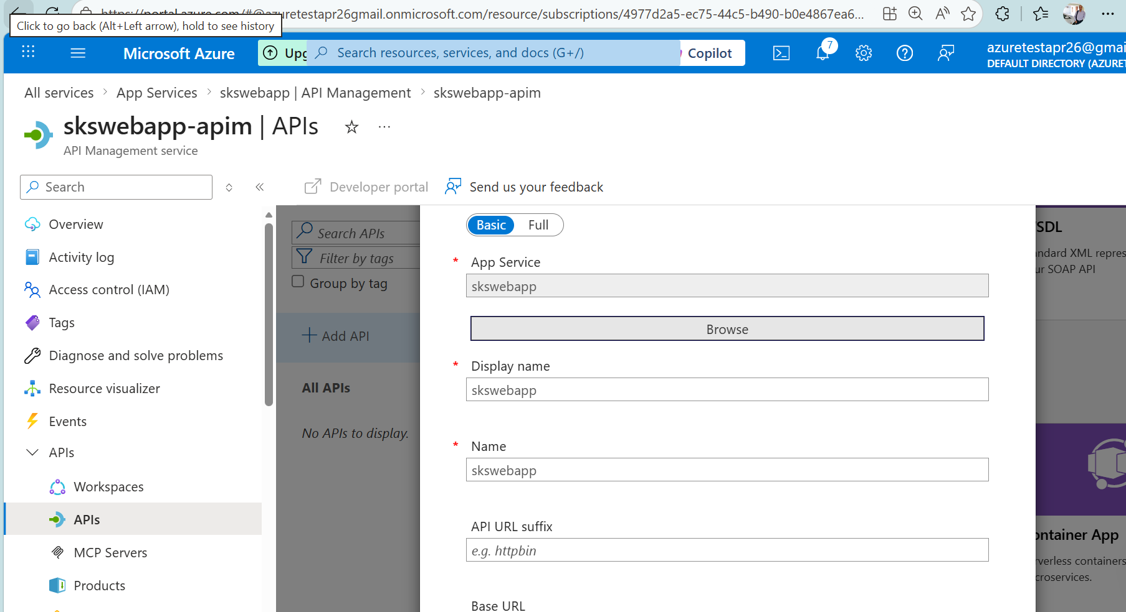

Goto apim settings – disable apikey
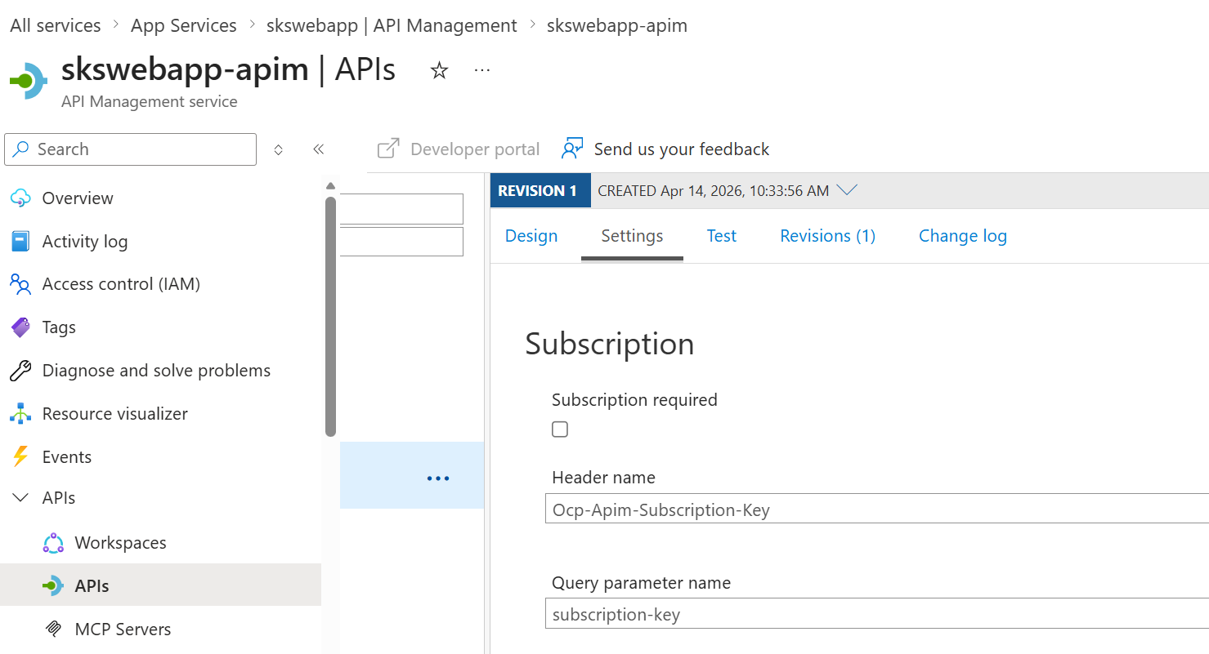

Test on browser
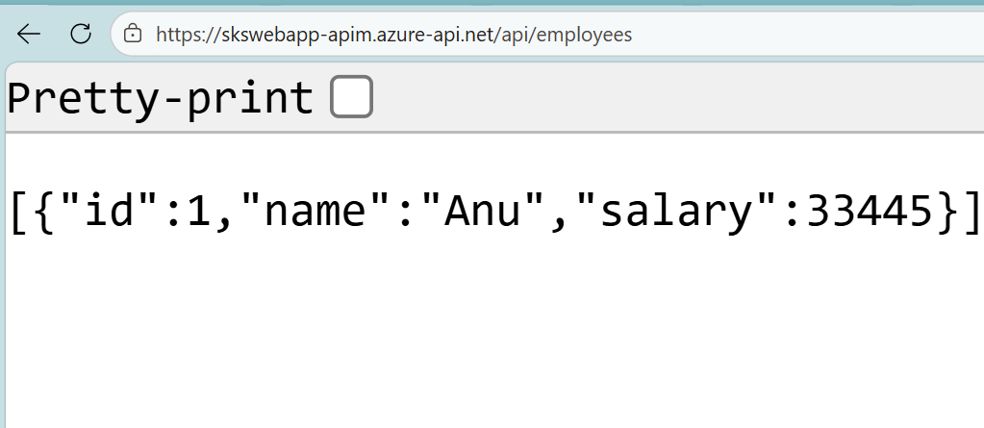

Goto Products – add product Starter – with require subscription
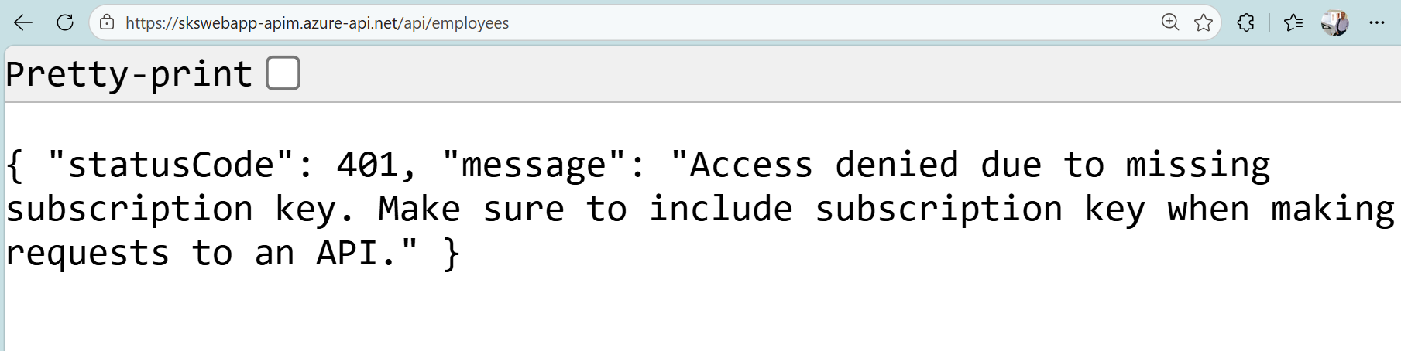

Product – subscription – add subscriber
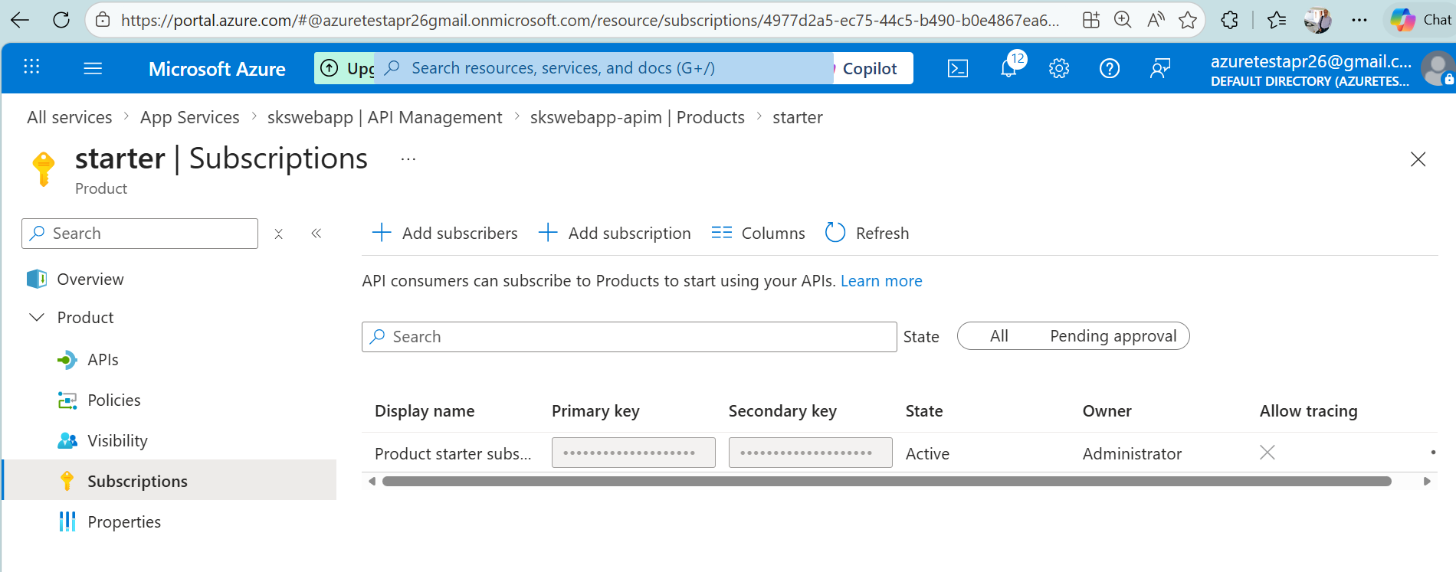

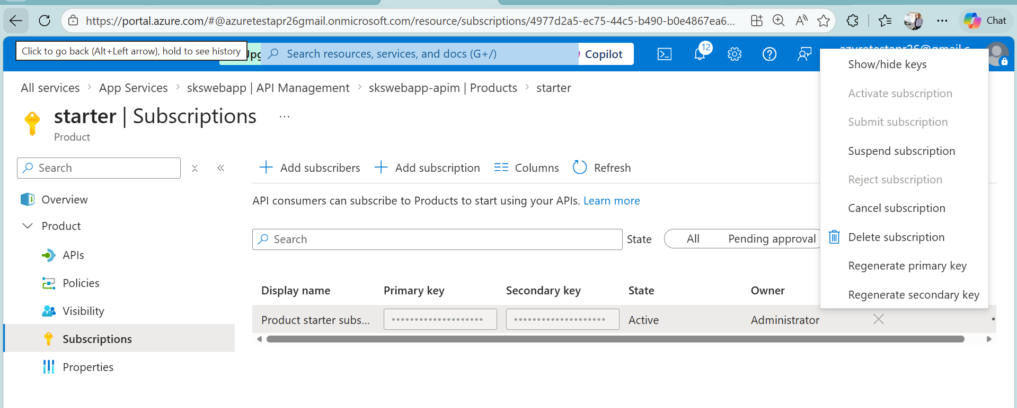

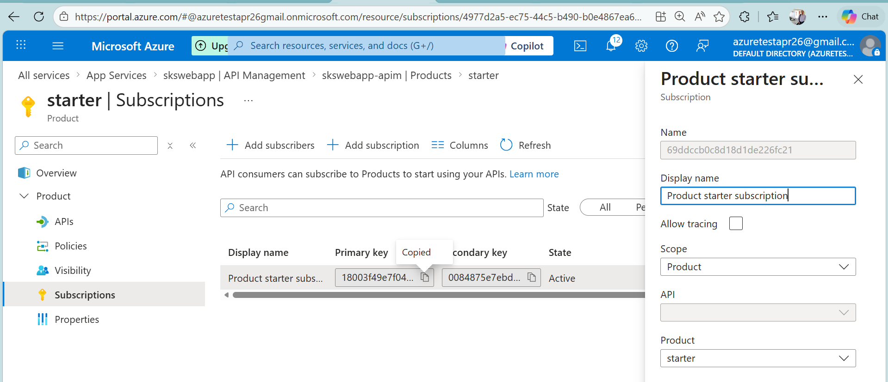

Copy primary apikey
Pass on get request

Check in postman
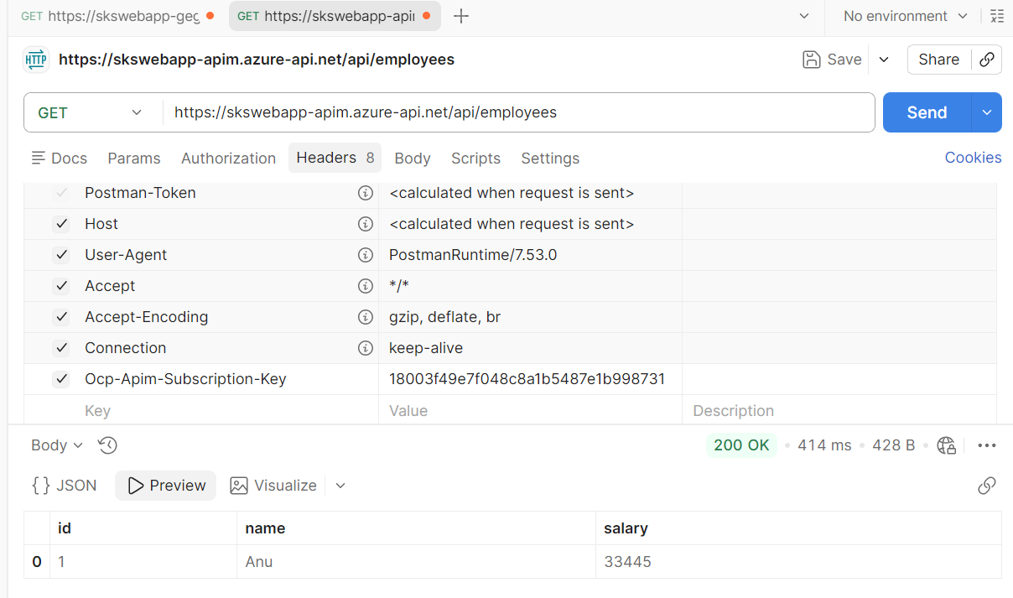

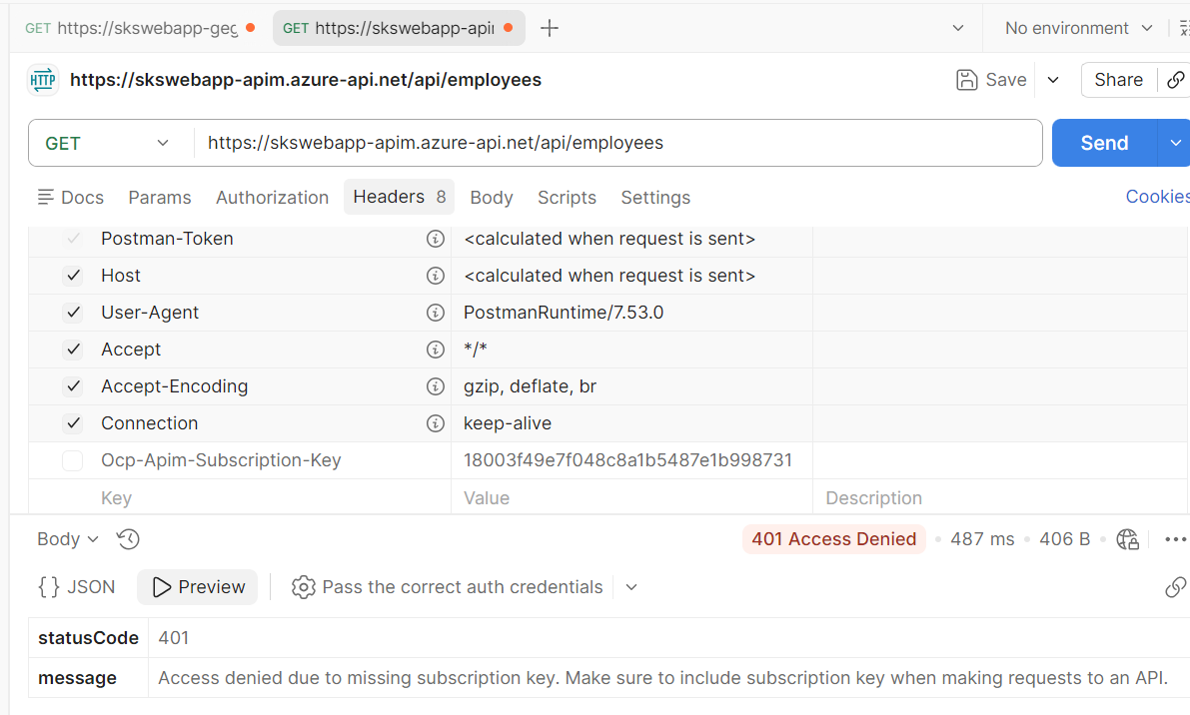

Apply Policies (Core Demo Highlight)
Go to:
APIM → API → Design → Inbound Processing

1️⃣ Rate Limiting
<rate-limit calls="3" renewal-period="60" />
👉 Demo:
- Call API 4 times → last call fails

<inbound>
<base />
<set-backend-service id="apim-generated-policy" backend-id="WebApp_skswebapp" />
</inbound>

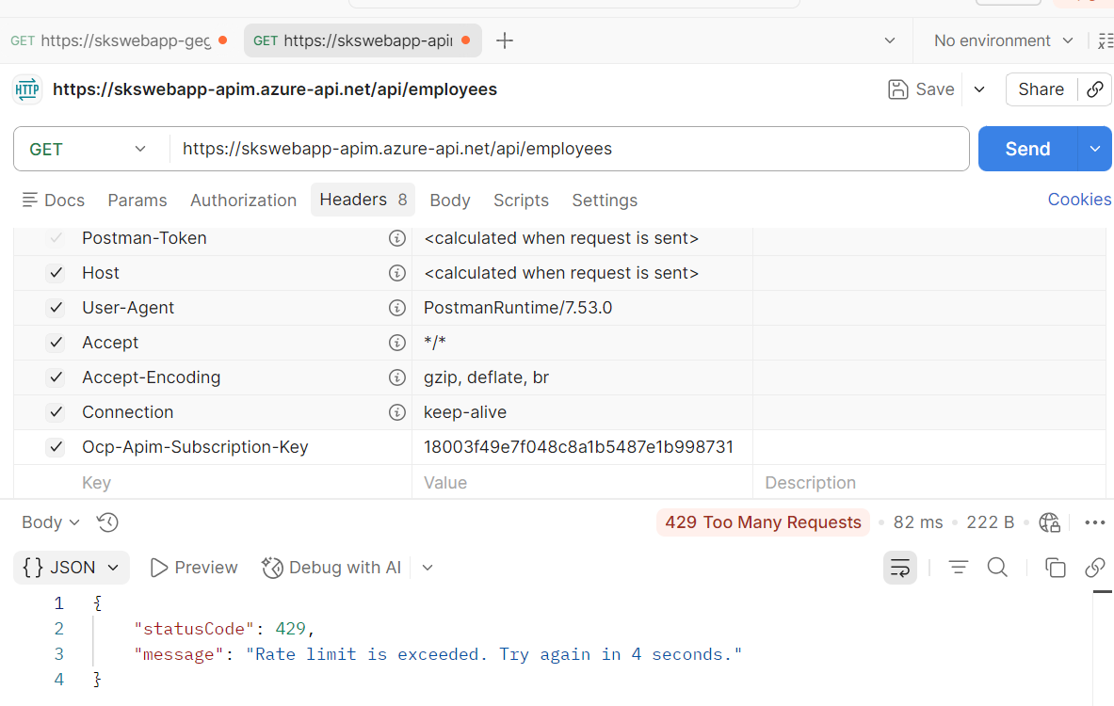

Monitoring & Analytics
Inside APIM:
- Metrics → Requests, Latency

Versioning (Advanced Demo)
In APIM:
- Add Version → v2
- Change endpoint:
/api/v2/products
👉 Show:
- Multiple versions handled centrally

Function App
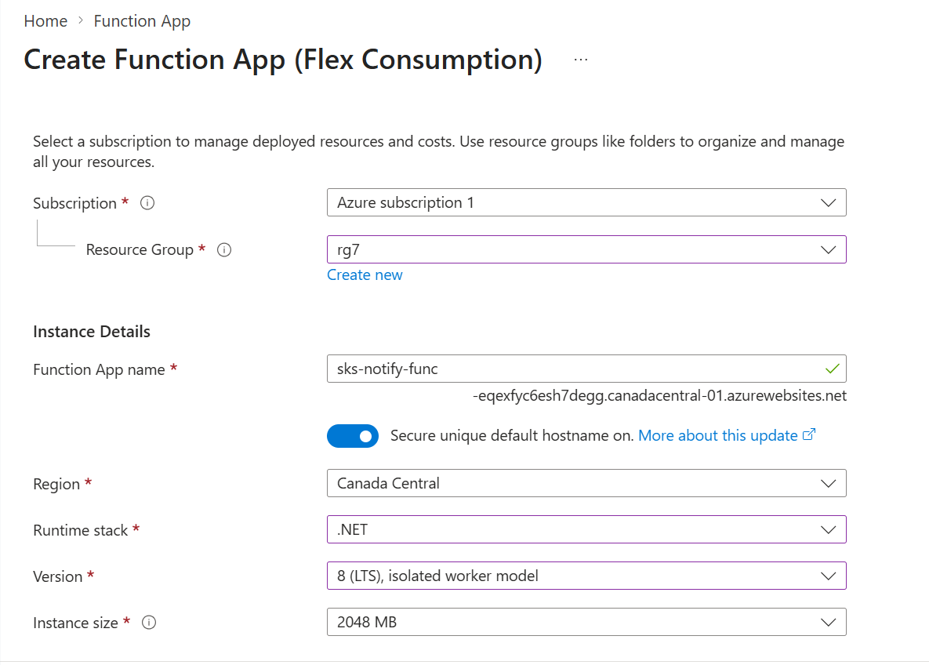

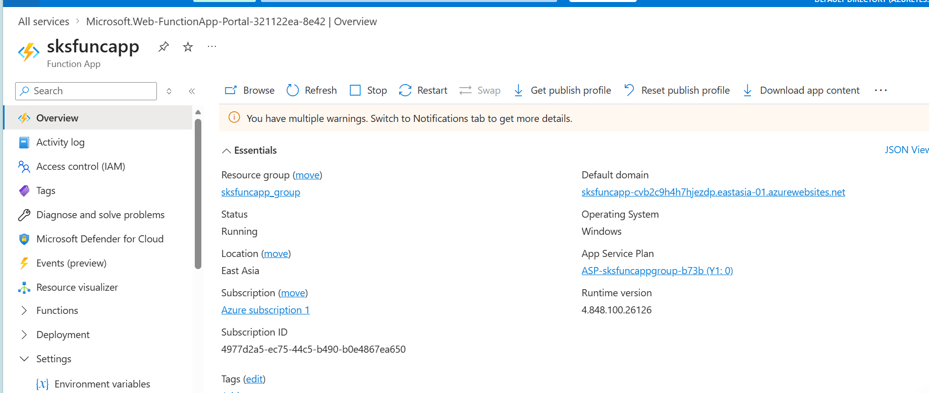

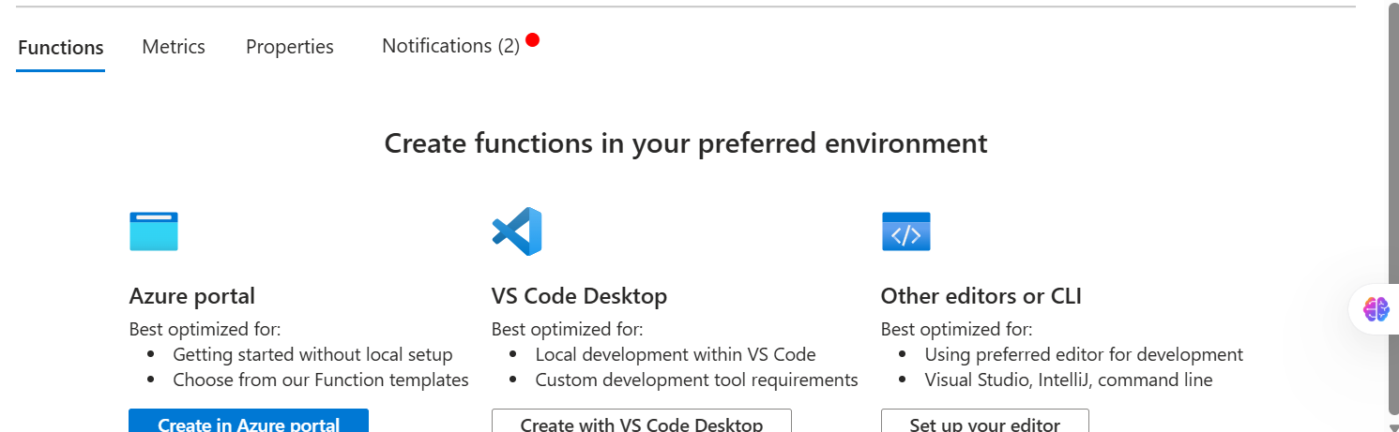

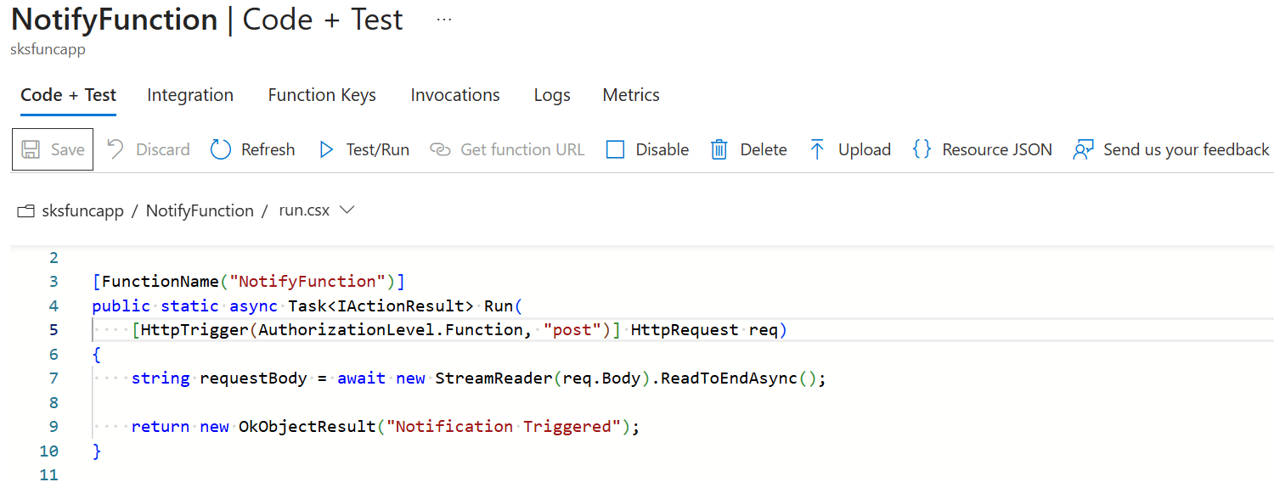

https://sksfuncapp-cvb2c9h4h7hjezdp.eastasia-01.azurewebsites.net/api/ SendEmailFunction
?code= xClERoYBC2vrtqKv5el_s4eWzpguB9p6NOeTpEivLy7eAzFuRg5UIA==

https://sksfuncapp-cvb2c9h4h7hjezdp.eastasia-01.azurewebsites.net/api/SendEmailFunction?code= xClERoYBC2vrtqKv5el_s4eWzpguB9p6NOeTpEivLy7eAzFuRg5UIA==

add logic app
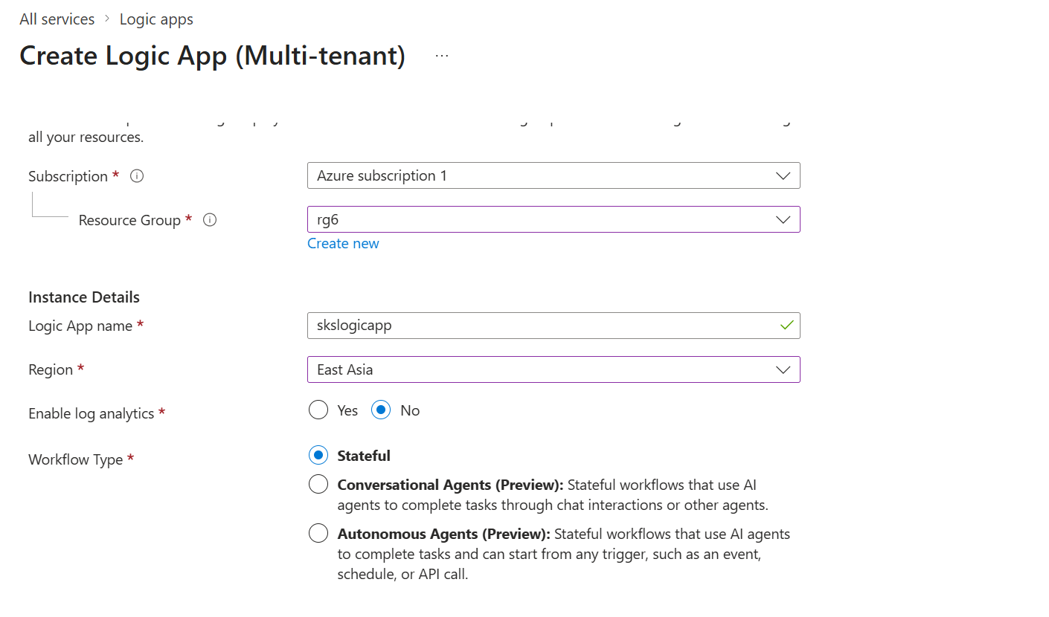
Add steps using designer
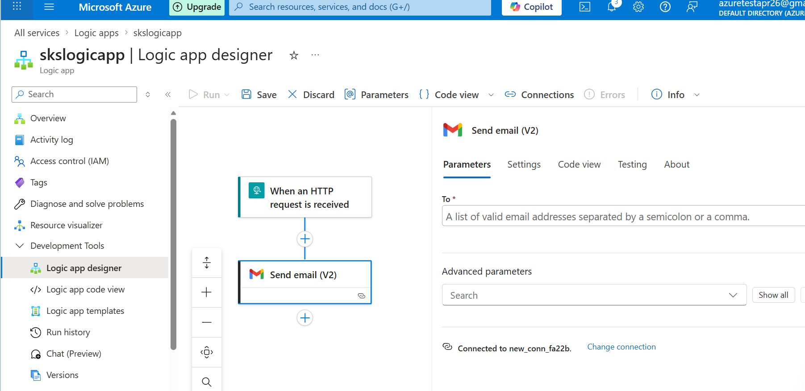

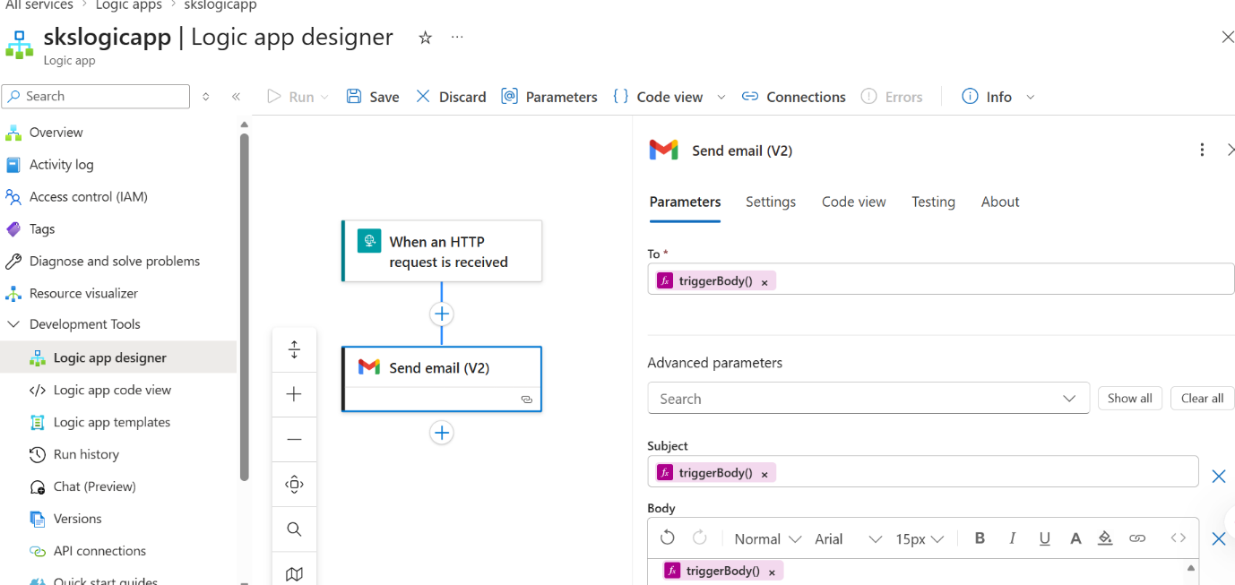

Run with Payload
